**Objective**: At the end of this lab session, you will learn to connect a windows form application with MS SQL Server database.

**DB Connectivity**

Section 1

Follow below steps.

1. Run Microsoft Visual Studio 2019 and open the application.

**( file → Open Project/Solution → WindowsFormsApp1 )**

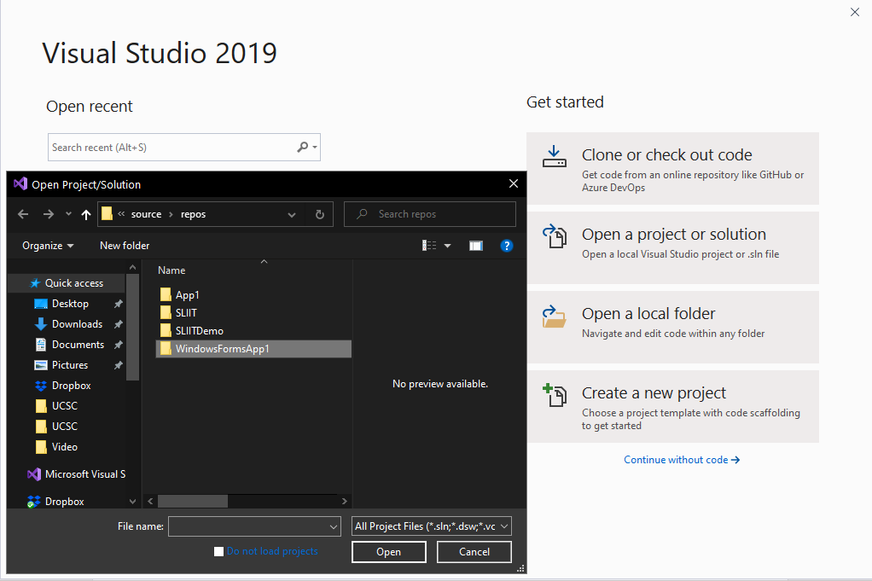

1. This is your Windows Form Application

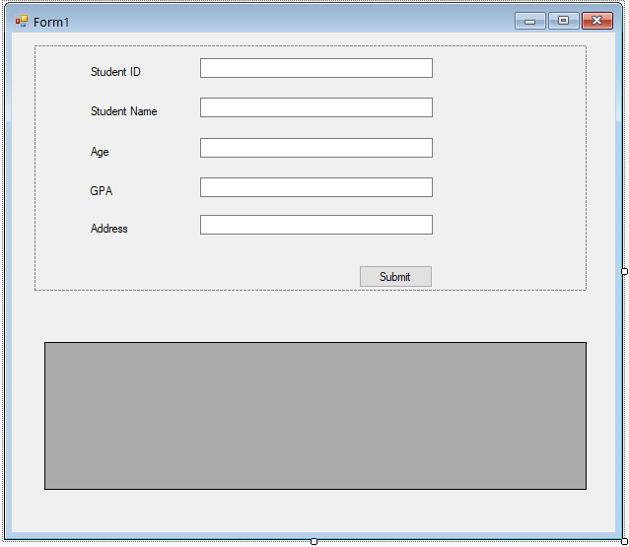

**Getting familiar with Microsoft SQL Server**

1. Connect to the SQL Server.

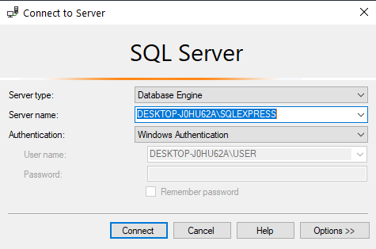

1. Create a New Database. (**Databases → New Database** )

Name the Database as **Student**

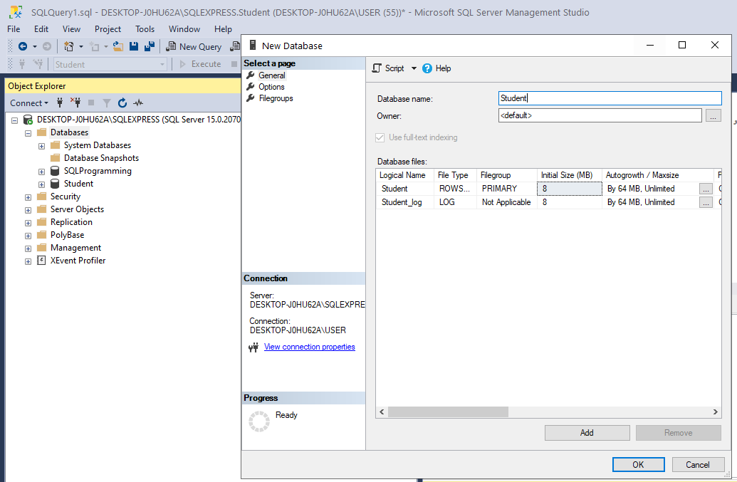

1. Create the following table in the Student Database

CREATE TABLE Student (

ID INT PRIMARY KEY,

Name VARCHAR (50),

Age INT,

GPA FLOAT,

Address VARCHAR (50)

);

Section 2

**Connect Windows Form application with MS SQL Server database**

In order to connect to a database, we need to provide connection details to the application.

The first step is to create an instance of the Server object to establish its connection to an instance of Microsoft SQL Server.

The SqlConnection Object is handling the part of physical communication between the C# application and the SQL Server Database.

1. First you need to add **a new connection**.

**Server Explorer → Data Connection → Add Connection**

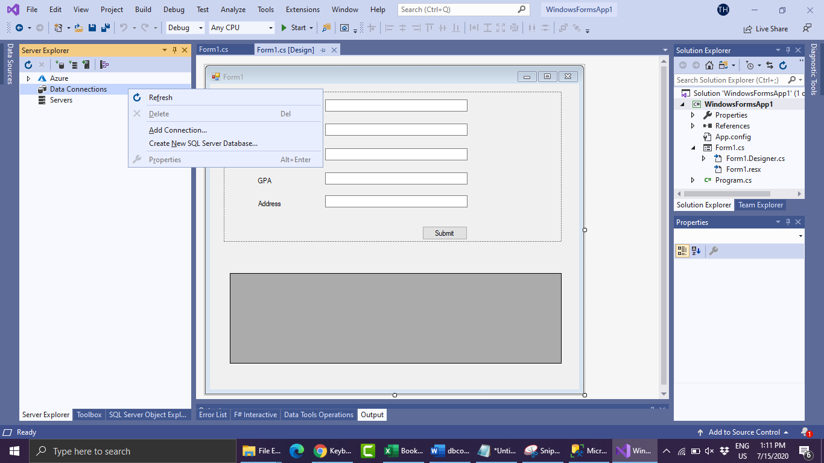

1. Select the Server which you want to connect
2. Select the database to connect.

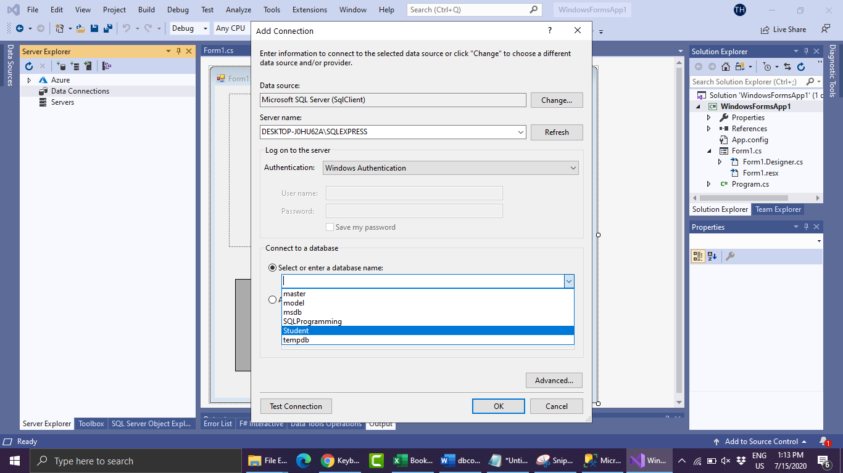

Now the Data Connection was created.

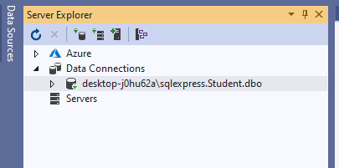

**Connection String**

Connection String is a string with information that allows you to connect with database from any program.Now you need to retriave this string.

1. Right click to Data Connection just newly created and select Properties

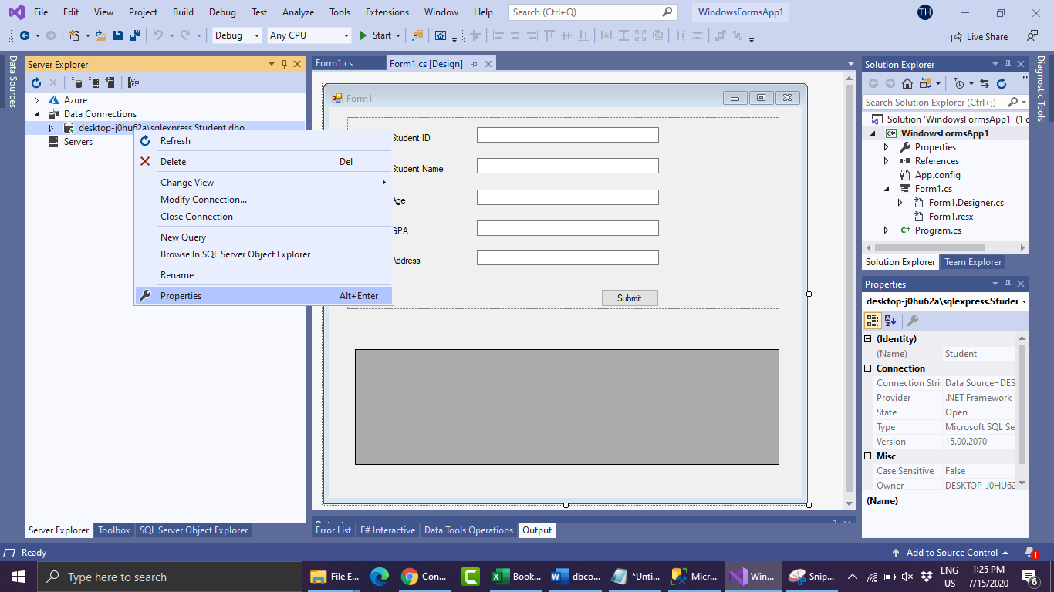

1. Go to the properties and copy the connection string.

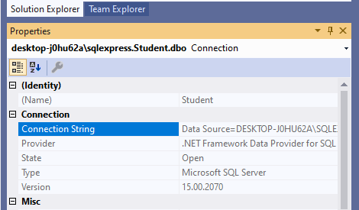

1. Paste it within **@””** tag as shown in the example inside the getConnectionString() method.

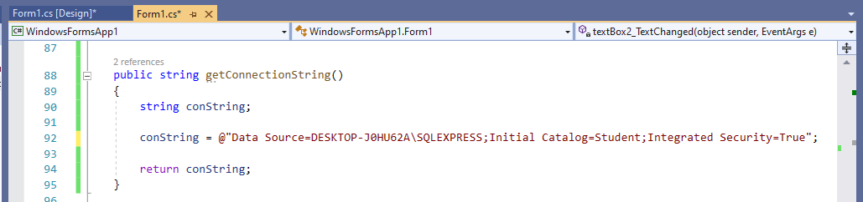

Now your connection is established with MS Sql Server.

**Insert data to the SQL Database**

1. Run the windows application.
2. Fill the form and click Submit button.

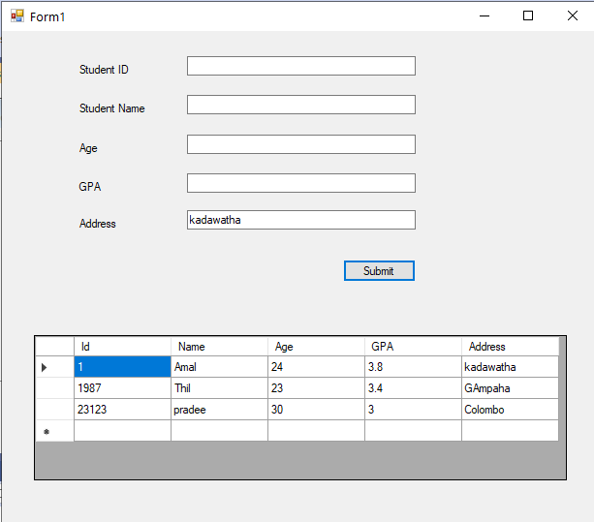

Now you can insert student data to the student database. Also you can open SQL server and view the data you entered.